**Leader Overview**

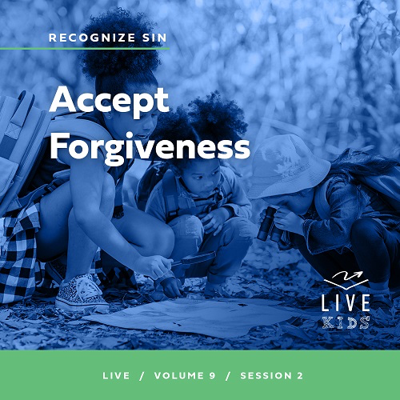

**Volume Overview**

**Recognize Sin**

*The Bible has a lot to say about sin and forgiveness. It acknowledges the deep brokenness of this world and our individual life. It is only by understanding the depth of human sin that we can understand the remarkable work of God’s forgiveness. Because of His forgiveness, we escape the eternal consequence of our sin and can rightly respond to the call to live a holy life. We learn to receive forgiveness, put off sin, and show forgiveness to those who have sinned against us. We learn to pursue holiness in the midst of the world’s brokenness.*

**Session Overview**

**Accept Forgiveness**

*In this* **Live** *session, kids will discover that we need forgiveness from God to be in right standing with Him. Even though we pursue sinlessness in our life and encourage others to do the same, we still need to accept God’s mercy and forgiveness to wipe away our previous sins and mistakes. This mercy, though we don’t deserve it, shows God’s heart for a relationship with us.*

**Bible Lesson**

A Woman Caught in Sin Receives Mercy

[John 8:1–11](https://ref.ly/logosref/Bible.Jn8.1-11)

**Faith Fact**

I can accept God’s forgiveness.

**Faith Verse**

[2 Corinthians 5:17](https://ref.ly/logosref/Bible.2Co5.17)(NLT)

Anyone who belongs to Christ has become a new person. The old life is gone; a new life has begun!

**Preparing for the Session**

**Leader Preparation Time: 20–25 Minutes**

|  |
| --- |
| ***You Will Need***  ***Large Group***   * *Bible* * *Worship songs (Song suggestions: “Free Indeed” Lyric Video by Planetshakers; “I Thank God” Lyric Video by Maverick City; “Trust” Lyric Video by Hillsong Young and Free; “Reckless Love” Lyric by Cory Asbury)* * *For groups not using a phone or tablet only, add:*   *• Projector or TV*  *• Laptop*  *•* ***Faith Fact Slide***  *•* ***Faith Verse Video*** *or* ***Slide***  *•* ***Bible Lesson Video***  *•* ***Teaching Point Slides 1–3***   * *Table* * *Chairs, two* * *Tests, two* * *Pencils, two*   ***Small Group***   * *Small ball* * *Bibles for kids in the group to share* * *Stones, one per group* * ***Small Group Activity Page****, one per kid* * *Pencils or pens, one per kid* * *Whiteboard* * *Dry erase markers* * *Whiteboard eraser* * *Small ball*   *To access session content and videos from a computer, visit:* [*BibleEngagementProject.com/downloads*](https://bibleengagementproject.com/downloads) |
| ***Getting Ready***  ***Large Group***   * *Download videos and slides if needed.* * *Select worship song(s) and have them ready to play.* * *Read the Bible Lesson Scripture to prepare for Teaching Time.* * *Place the table, chairs, and supplies so all the kids can see.*   ***Small Group***   * *Print copies of the* ***Small Group Activity Page****, one per kid.* * *Write the Faith Verse on the whiteboard before the session.*   *First time leading* Live *for Kids? Check out the* [*Facilitator Guide*](https://0b769b0ed3569ef9d18b-f88d8272f61086866d50d048b43ef630.ssl.cf2.rackcdn.com/sites/biblengagementproject/Listen_Facilitator_Guide.pdf)*.* |

**Large Group**

**30 Minutes**

*See what’s needed at the beginning of the session.*

**Introduction**

Hello, everyone! Today will be amazing as we learn more from God’s Word *(hold up the Bible)* together. We talked last time about leaving sin behind. Raise your hand if you want to make sure you experience everything God has for you. *(Group response)* I really want that too!

Sometimes we make mistakes that get in the way of that happening. Today, we’ll talk about what we should do when we sin and how we can make sure we do better the next time we’re tempted.

Have you ever been caught doing something wrong? Raise your hand if that has happened to you. *(Group response)* I think that has happened to all of us, and no one would ever say that’s a good feeling. Nobody wants to be in trouble, but people make mistakes. Sometimes those mistakes lead to sin. What’s amazing is that God loves us and wants to forgive us.

**Faith Fact**

I‘m so thankful for our Faith Fact for today. It is **I can accept God’s forgiveness.** In our Bible story today, we’ll see that Jesus showed forgiveness to a woman who was caught in sin.

• *Show the* ***Faith Fact Slide.***

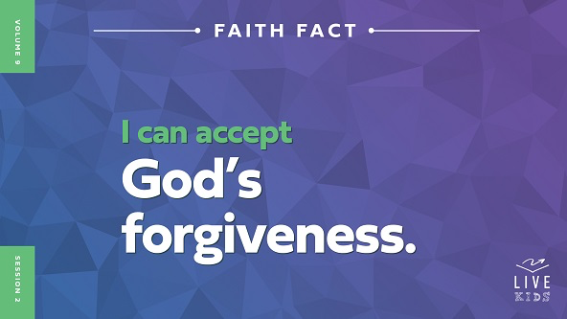

God is full of love for us, so He is willing to forgive us when we sin. Point at yourself, then up to God and say, **I can accept God’s forgiveness.** Let’s say it one more time. **I can accept God’s forgiveness.** Well done!

**Game**

**Museum**

Let’s start with a fun game called Museum. Here’s how the game works. There will be one museum worker, and the rest of you will be statues in the museum. The worker will patrol around, inspecting the statues and looking for any movement. Meanwhile, the statues will try to move around when the museum worker isn’t looking at them. If you are caught moving, then you are out and must sit down until the next round. The last person standing is the museum worker for the next round.

• *Encourage kids to not stay perfectly still and encourage the worker to not stand in one spot where they can see all the other kids at once.*

• *Consider adding a challenge for the statues, like all statues moving to a central location to win against the guard.*

Good job, everyone! You did great in this game by being sneaky and trying not to get caught. In the game, no one was sneaking around because they did anything wrong. Sometimes when we do something we know is wrong, we try to sneak around and hide it from our parents, teachers, or friends because we don’t want to be caught. Have you ever thought about doing that? *(Group response)* There is Someone we can never hide things from. Who is that? *(Group response)* Thankfully, God is willing to forgive us when we do something wrong and sin. Let’s say the Faith Fact together. **I can accept God’s forgiveness.**

**Worship**

Something that can make it easier to recognize our need for God’s forgiveness is worshipping Him in different ways. When we worship God, we remind ourself of how great His love for us is. He will forgive our sins when we ask because of His love for us. Who’s ready to worship God by singing? *(Group response)* Let’s worship Him together.

• *Lead the kids in singing one or two praise songs. See suggestions at the beginning of the session.*

**Bible Lesson**

Thanks for singing and worshipping with me, everyone. When we worship God, we want to honor Him more and more, which helps us recognize anything in our heart, mind, or life that is holding us back. When that happens, remember our Faith Fact. **I can accept God’s forgiveness**. We’ll see what the Bible says about this. Let’s pray and then look at our Bible story.

**Prayer**

|  |
| --- |
| *Dear God, thank You for being willing to forgive all our sins. Help us learn how to accept forgiveness from You so that nothing ever gets in the way of us experiencing all the love You have for us. In Jesus’ name. Amen.* |

**Video Intro**

Before we look at the Bible story, let’s watch this video.

• *Play* ***Bible Lesson Video****.*

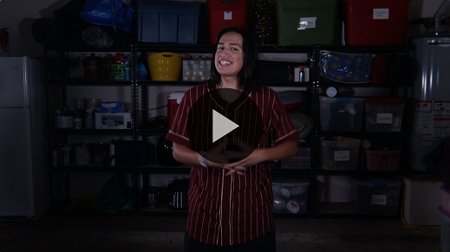

**Bible Story**

**A Woman Caught in Sin Receives Mercy**

Have any of you ever been in a situation like Dash before? *(Group response)* We’ll talk more about that later. It’s not easy to face getting in trouble when we get caught doing something wrong. It sounds like he learned a lot about forgiveness. Let’s look at God’s Word together to learn more about accepting forgiveness from God.

**Teaching Time**

|  |
| --- |
| ***You Will Need***   * *Table* * *Chairs, two* * *Tests, two* * *Pencils, two*   ***Getting Ready***   * *Place the table, chairs, and supplies so all the kids can see.* |

In the verses we’ll read, Jesus had been teaching people. Many people listened to Him and believed, while many others didn’t want to accept that He truly was God’s Son. In fact, some of those people who didn’t want to listen to Him tried to come up with ways to trap Him so they could get rid of Him!

Some Pharisees were part of that group. Why do you think those people didn’t like Jesus so much? *(Allow responses.)* They probably felt threatened by Jesus. They took their job seriously, but their hearts weren’t open to hear the truth that Jesus was telling them. Jesus was about to not only outsmart some Pharisees but also teach about what forgiveness truly means to someone they were trying to punish. Jesus wanted them to live out our Faith Fact. Let’s say that all together! **I can accept God’s forgiveness.**

Grab your Bible or pull up a Bible app on your device. Turn to [John 8:1–11](https://ref.ly/logosref/Bible.Jn8.1-11).

• *In order to keep Large Group time moving along, we recommend that the leader reads the Scripture portions aloud.*

• *Optional: Remind the kids to mark this place with their Bible bookmark so they can read it on their own at home.*

**1. A woman was caught in sin.**

• *Show the* ***Teaching Point 1 Slide.***

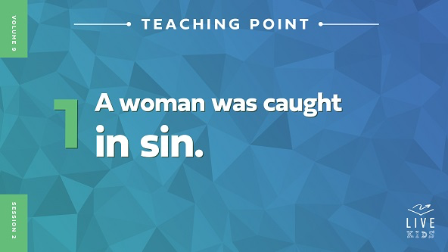

• *Read* [*John 8:1–4*](https://ref.ly/logosref/Bible.Jn8.1-4)*.*

Wow! This situation sounds pretty intense! This woman broke the promises she made to her husband when they got married. That’s a really serious mistake. The Pharisees took this woman to Jesus and told Him and the crowd around Him what she had done wrong. That would be so embarrassing!

Can you imagine what the woman was feeling in that moment? *(Group response)* I’m sure she felt upset, embarrassed, ashamed, and many other things. She knew what she’d done was wrong, but the way this was being handled by the Pharisees was not God’s way to punish also.

• *Sit at the table and invite a kid volunteer to sit next to you to be a student.*

• *Begin acting out the scene as you share.*

I want you to imagine something like what happened to Dash in our video. Only this time it’s about you. Your class is taking a test at school. *(Look worried as you “work” on the test.)* You start to worry about how you are doing. You look over your neighbor’s shoulder and start copying off their test. Is that right or wrong? *(Group response)* It’s wrong! We definitely shouldn’t cheat.

Now, imagine that someone in your class saw you doing this, and they raised their hand and said in front of everyone, “Teacher, someone is cheating!” I mean, cheating is wrong, but having that shared with everyone in the class would be so embarrassing and uncomfortable. Now, you’re in the spotlight, and everyone is looking at you, wondering what will happen. That’s similar to what this woman probably felt.

These Pharisees didn’t care because they were focused on trying to get Jesus to say the wrong thing. They wanted to ask Jesus a question about this woman’s situation to trap Him, but He was ready for it. Let’s see what happened next.

**2. Jesus was smarter than the Pharisees.**

• *Show the* ***Teaching Point 2 Slide.***

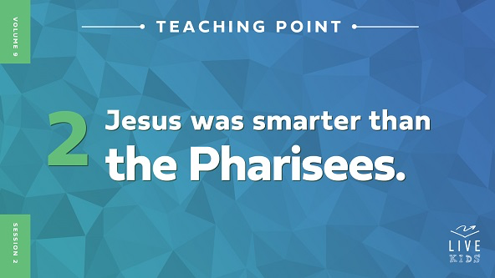

• *Read* [*John 8:5–9*](https://ref.ly/logosref/Bible.Jn8.5-9)*.*

The Pharisees asked Jesus what should be done to the woman. They thought they already knew the answer to that question. According to laws that were set a long time ago, if a man and woman committed certain sins, they should have stones thrown at them until they die. That’s really intense, right? *(Group response)* So, if they could catch Jesus saying God’s laws weren’t important, then they could get Him in trouble.

Jesus was ready for their question. Instead of directly answering the question they asked, He turned things back on them. He said that anyone who had no sin, or who had never made a mistake, could throw the first stone at the woman. Do you think any of the Pharisees could say that was true about them? *(Group response)* Of course not! Everyone who was standing there began to leave because they had all sinned. Only Jesus could have chosen to hurt the woman.

• *Act out the school scenario again as you share it.*

Let’s imagine our school situation again. Imagine your classmate tells your teacher, “The rules for school say that anyone caught cheating on a test gets a zero for it. Give this kid a zero!” You know that your parents would be really mad if you got caught cheating, so you’re nervous.

Then your teacher looks at everyone in the room and says, “Has anyone here never broken any school rule? If so, you are the only one who can talk about how this student should get a zero on the test.” Do you think anyone at school has been perfect and obeyed all the rules all the time? *(Group response)* I don’t think so. Slowly, everyone would start to go back to their work.

Is the rule about cheating on a test a bad rule? *(Group response)* No, cheating is wrong. In this situation, the teacher would be telling the other students that they are not the ones who get to enforce the rules. Each of us has done something we weren’t supposed to at school and disobeyed some rule. Up next, we see the best part of the story. Let’s check it out!

**3. Jesus forgave the woman.**

• *Show the* ***Teaching Point 3 Slide.***

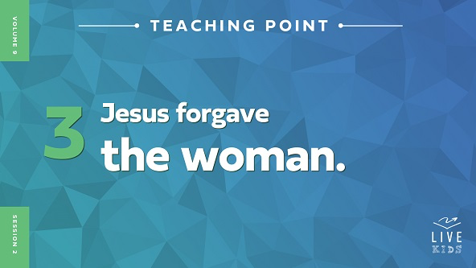

• *Read* [*John 8:10–11*](https://ref.ly/logosref/Bible.Jn8.10-11)*.*

Wow! Can you believe what Jesus did? *(Group response)* He was perfect, so He could have punished her. Instead, Jesus looked at her, forgave her, and sent her on her way. He also told her to leave behind her life of sin. How do you think the woman felt when Jesus did that? *(Allow responses.)* I’m sure she felt so relieved and grateful for Jesus’ wisdom and forgiveness.

• *Continue to act out the school scenario.*

Let’s compare that to our school situation. You cheated on a test, and someone caught you. The teacher said only people who had never broken the rules could decide how you should be punished. No one could because no one is perfect. Then, the teacher calls you over and says, “Hey. You can’t cheat on a test. It’s unacceptable. But, I forgive you. Go back and finish your work. And don’t ever cheat again.” How would you feel? *(Group response)*

Again, the rule to not cheat on a test and the rule to not commit adultery are good rules. God gives us rules and guidelines because He knows that some things we may be tempted to do are bad for us. At the same time, God doesn’t want to embarrass us or cause us to feel ashamed because of our sin. He wants us to turn to Him, accept His forgiveness, and move on.

Jesus clearly told the woman not to sin anymore. Before that, He said that He didn’t condemn her, which means He didn’t hold any of her sins against her. That’s why we need to remember our Faith Fact today. **I can accept God’s forgiveness**. God wants to help us recognize the sin in our life so that we know what we need to ask forgiveness for.

**Prayer and Response**

*Consider playing a worship song softly in the background while kids pray.*

Accepting God’s forgiveness means we believe that Jesus paid for all the wrong we could ever do by giving His life for us. By dying on the Cross, His perfect life paid for all our sins.

Today, I want to give an opportunity for anyone who has never asked Jesus for His forgiveness to do it. When we do that, all our old sins are wiped away. If you’ve never made that decision to ask Jesus to forgive your sins and invite Him into your life, I want to give you a chance to do that now.

• *Ask anyone who wants to make this decision to come to the front to pray with you or another leader.*

God loves you so much, and He wants you to know you are forgiven. God is so good! He will be with you always, He will forgive you, and He will help you make better choices that honor Him and show His love to the world around you.

**Prayer**

*Optional: Have the kids repeat phrases of the prayer after you.*

|  |
| --- |
| *Dear God, thank You for Your forgiveness. I don’t deserve it because I’ve made mistakes, but I’m grateful for it. Help me to remember that I don’t have to work for Your forgiveness and that You want to help me follow You more and more every day. In Jesus’ name. Amen.* |

**Faith Verse**

Our Faith Verse reminds us that when we follow Jesus, we are a totally new person. Nothing from our old life can keep us away from Him!

• *Play* ***Faith Verse Video****.*

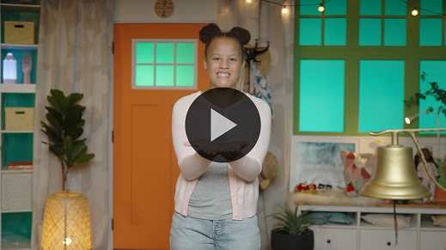

[2 Corinthians 5:17](https://ref.ly/logosref/Bible.2Co5.17) (NLT)

Anyone who belongs to Christ has become a new person. The old life is gone; a new life has begun!

Let’s say that verse together, all at once! *(Group response.)* Great work.

**Faith Fact**

Before we go to our small groups, let’s review our Faith Fact again. **I can accept God’s forgiveness.**

• *Show the* ***Faith Fact Slide****.*



Let’s say that Faith Fact together. **I can accept God’s forgiveness.** Point at yourself and then up to God. Let’s say it one more time. **I can accept God’s forgiveness.**

• *Dismiss kids to Small Group time or to go home if your group time ends here.*

**Small Group**

**30 Minutes**

*This section can be done in conjunction with the large group or on its own if you do small groups with your kids. During Small Group time, the goal is to connect the kids with the Word of God and to each other. All activities are led by the small group leader.*

**Group Connection**

**“I Needed Forgiveness When . . .”**

|  |
| --- |
| ***You Will Need***   * *Small ball*   *No prep needed for this activity.* |

In our Bible story, we heard about how Jesus showed forgiveness and encouragement to a woman who had made a big mistake. God wants us to do the same to those around us, but we also are called to accept forgiveness from God like the woman did in the story.

Today, we’ll take turns passing around this ball. *(Hold up the ball.)* Whoever has it gets to speak. When you get the ball passed to you, briefly tell a story about when you made a mistake and needed forgiveness from someone else. Let’s try to pass this around to everyone.

• *Pass the ball around the group.*

• *Be sure each kid has a chance to speak.*

**Bible Lesson Recap**

• *If small group activities are not immediately following large group time, you may want to read the Bible story passage before the discussion.*

|  |
| --- |
| ***You Will Need***   * *Bibles for kids in the group to share*   *No prep needed for this activity.* |

**Bible Story Review: A Woman Caught in Sin Receives Mercy** [**John 8:1–11**](https://ref.ly/logosref/Bible.Jn8.1-11)

What was the most interesting thing about the Bible story we heard today? *(Allow responses.)* Those are great answers! To review, a woman was caught in sin, Jesus was smarter than the Pharisees who brought the woman to Him, and then Jesus forgave the woman for her sin.

If we don’t accept God’s forgiveness, then we will always feel like something is wrong with us or that we aren’t good enough to be doing what God is calling us to do. He wants so much more for us than that.

• *Give each kid a Bible and read the Bible story together.*

**Group Discussion**

*Feel free to use all or just a few questions as a jumping-off place for good discussion. Questions marked with * are designed for more conversation. Adjust the questions based on the age or maturity of your group. Typically, older kids will be able to dive a little deeper than younger ones.*

**Questions**

What did the rules say could happen to the woman because of her sin?

* Why did the Pharisees try to trap Jesus with a tricky question?

How do you think the woman felt about being the center of attention for doing something wrong?

* How do you think the Pharisees reacted to Jesus saying that anyone without sin could throw the first stone at the woman?

What did they do after Jesus gave them this instruction?

* Does God’s forgiveness ever run out? Why do you think that?

Can we keep sinning if we want to and just be forgiven every time?

* Why is it important to accept God’s forgiveness?

Do you need to accept God’s forgiveness for anything that you have recently done?

**Live It**

**Faith Fact**

Our Faith Fact is **I can accept God’s forgiveness.** Jesus showed that it’s important to have God’s forgiveness in our life. It shows us that God doesn’t hold our sins against us. Plus, it gives us the freedom to follow God with a fresh start.

**Challenge**

The challenge for this week is to thank God every morning with a special prayer that you will see on your Activity Page in a few minutes. Take it home and place it somewhere that you’ll see it as a reminder. Thanking God every day for His forgiveness will remind you that He loves you and will encourage you not to sin.

**Prayer**

*Finish group discussion by sharing prayer requests and praise reports. Keep track of your small group’s prayer requests and review them each time you meet.*

• *Have kids share and pray for each other’s prayer requests.*

|  |
| --- |
| *Dear God, thank You for hearing us when we pray. Please help us understand Your forgiveness and love for us. Help us to want to honor You in our heart and mind. In Jesus’ name. Amen.* |

**Faith Verse Review**

|  |
| --- |
| ***You Will Need***   * *Stones, one per group*   *No prep needed for this activity.* |

Our Faith Verse is [2 Corinthians 5:17](https://ref.ly/logosref/Bible.2Co5.17). Jesus makes our life brand-new. Let’s go over our Faith Verse together.

• *Show* ***Faith Verse Video****.*



[2 Corinthians 5:17](https://ref.ly/logosref/Bible.2Co5.17) (NLT)

Anyone who belongs to Christ has become a new person. The old life is gone; a new life has begun!

Choosing to follow Jesus means that we get a fresh start in our life! The old parts of us are gone and we aren’t who we were anymore. God makes us new. Let’s review our Faith Verse as a group a couple of more times. Try to memorize it as best as you can because you will need to know it for the Faith Verse game.

• *Say the verse as a group a couple of times.*

**Faith Verse Fun**

**Pass the Stone**

In our Bible story, Jesus challenged the woman’s accusers. He said they could only hurt the woman if they were without sin. *(Hold up the stone.)* Every one of them walked away. We’ll pass this stone around as a reminder to choose God’s forgiveness. As we pass it, try to say the Faith Verse one word at a time.

• *Help kids say the verse word by word as they pass the stone.*

I’m impressed that we’re memorizing the Faith Verse. More importantly, we need to make sure we are putting this verse into practice in our life.

**Activity Page**

**Prayer Decoder**

|  |
| --- |
| ***You Will Need***   * ***Small Group Activity Page,*** *one per kid* * *Pencils or pens, one per kid*   ***Getting Ready***   * *Print the* ***Small Group Activity Page****, one per kid.* |

Our Faith Fact is **I can accept God’s forgiveness.** We don’t want anything in the way of God’s best for our life.

• *Hand out a copy of the* ***Small Group Activity Page*** *and a pencil to each kid.*

We talked earlier about thanking God for His forgiveness every day. Here’s an example of a prayer you could pray. All you need to do is decode the letters of some specific words.

• *Give kids time to complete the* ***Small Group Activity Page.***

**Dismissal**

Remember that God loves us so much that He is willing to forgive us when we sin. When we sin, we need to ask for His forgiveness and trust that He forgives just like He says He would in the Bible.

**Prayer**

|  |
| --- |
| *Dear God, please help us to accept the love You have for us. We know we don’t deserve Your forgiveness, but we need it because it helps us honor You better. We are so grateful for the love You show us every day. Help us live that and share it with others. In Jesus’ name. Amen.* |

**Faith Fact Recap**

• *Show the* ***Faith Fact Slide****.*



God wants to be close to us. That’s why our Faith Fact is not only important to remember but also to live out. Let’s say it together. **I can accept God’s forgiveness.** I’m so glad you came today. I can’t wait to see you next time**.**

• *Send home the* ***Small Group Activity Page.***

• *Remind parents that there are* ***Family Devotions*** *available on the app to do with their kid.*

• *Tell everyone the date and time for the next session.*